**CURRICULUM VITAE**

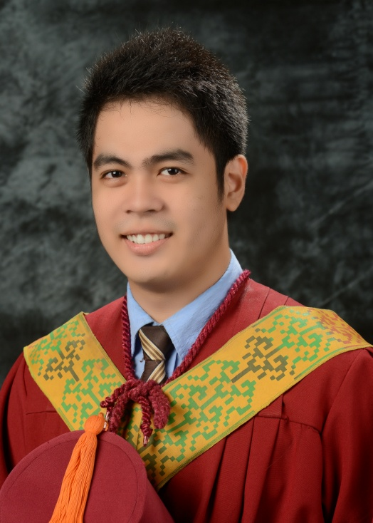**ALBERTO LUCAS SIEGA BELGERA**

Address**: P-3 Bosco District, Mangagoy, Bislig City,**

**Surigao del Sur**

Email Address**:** [**alsbelgera@gmail.com**](mailto:alsbelgera@gmail.com)

Mobile Number: **+639061002859**

Date of Birth: **September 18,** **1991**

Place of Birth: **Mangagoy, Bislig City**

Civil Status: **Single**

Religious Affiliation: **Roman Catholic**

Father’s Name: **Alejandro Luis Ayo Belgera**

Mother’s Name: **Ma. Leliza Siega Belgera**

Education

* Mindanao State University Iligan Institute of Technology (2008-2013)
* De La Salle John Bosco College (2004-2008)
* De La Salle John Bosco College (1998-2004)

Work Experience

* National Power Corporation, AGUS 6 & 7 Hydroelectric Power Plant On-The-Job Training(April-June 2012)

Affiliations/Positions

* COE-EC Sports and Development Committee Head (2011-2012)
* MSU-IIT Volleyball Varsity Men (2009-2013)
* Junior Institute of Electronics and Communications Engineers of the Philippines Member (2008-2013)

**CURRICULUM VITAE**

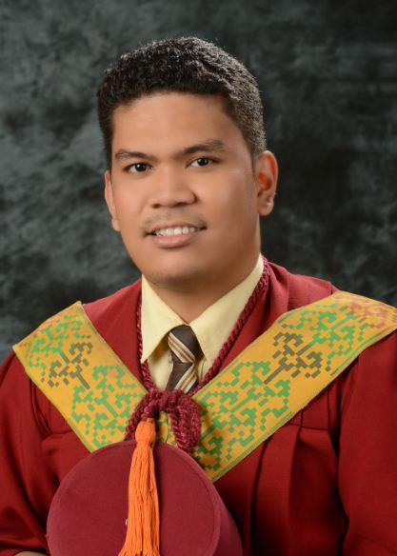**JAIME CENA PAGATPAT JR.**

Address**: P-1 Bogac District, Mangagoy, Bislig City,**

**Surigao del Sur**

Email Address**: jaime_pagatpat2000@yahoo.com**

Mobile Number: **+639061888167**

Date of Birth: **April 2, 1992**

Place of Birth: **Mangagoy, Bislig City**

Civil Status: **Single**

Religious Affiliation: **Islam**

Father’s Name: **Jaime Melocotones Pagatpat Sr.**

Mother’s Name: **Loreta Cena Pagatpat**

Education

* Mindanao State University Iligan Institute of Technology (2008-2013)
* De La Salle John Bosco College (2004-2008)
* Mangagoy Central Elementary School (1998-2004)

Work Experience

* National Power Corporation, AGUS 6 & 7 Hydroelectric Power Plant On-The-Job Training(April-June 2012)
* Virtual Assistant, Doctors Edge Marketing (2011-2013)

Affiliations/Positions

* JENESYS – Japan Network of Exchange for Students and Youths (April 2010)
* Initiative for Peace: Focus in Mindanao (May 2012)
* MSU-IIT Youth Chain of Peace (2012-2013)
* JIECEP Member (2008-2013)
* MSU-IIT DOST Scholars Association (2008-2013)
* Batch President, De La Salle John Bosco College, Batch 2008